**Title:** Task B-5 Report

**Author:** Robin Findlay-Marks, s103603871

**Task information:**

Subtask 1:

For this subtask I had to make the program go from predicting only one day into the future, to N days in the future (multistep). At first I had some difficulty figuring out how to do this. I found a bunch of tutorials of how to do this, but all of them had some issue about them which meant I couldn’t use them. What I ended up doing was making a loop to go through each future day that needs to be predicted. In this loop, it would first declare the ‘real_data’ npArray from model_inputs. It would then make the prediction of the next future day, and add it to real_data. It then adds predicted value to futurePrice and to the end of model_inputs.

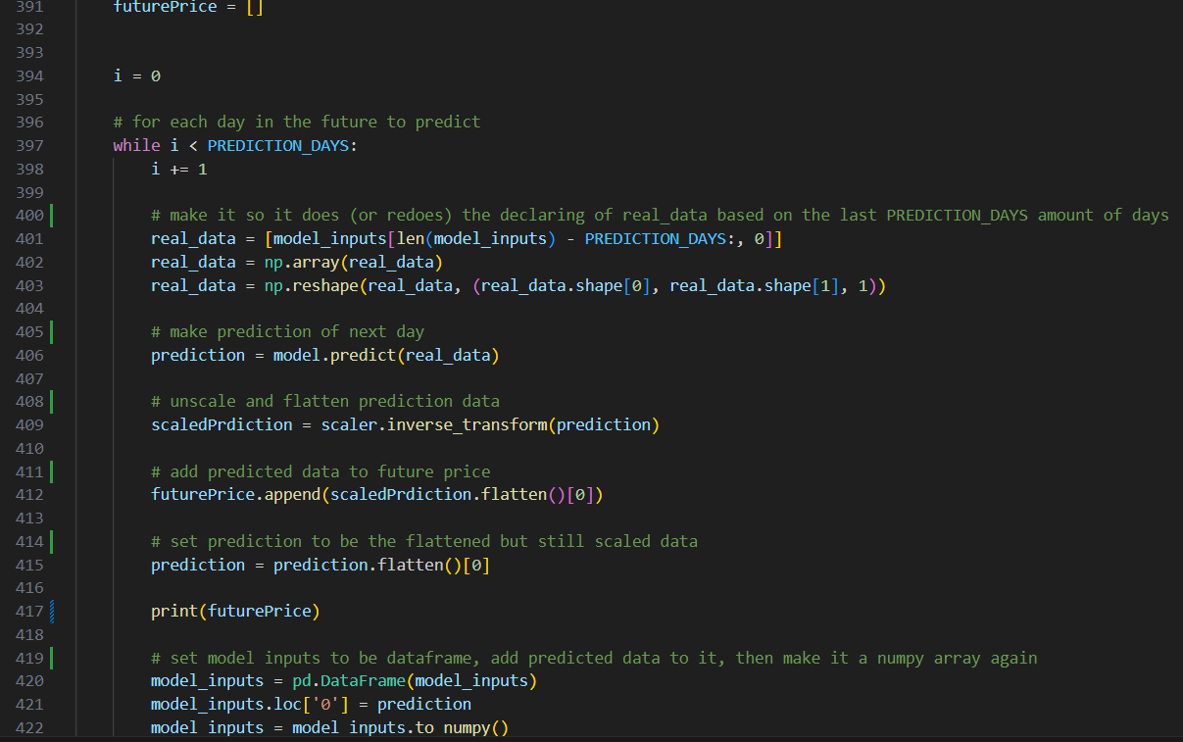

The next step was to make this predicted data actually display on the graph. This was fairly easy to do except that it would not appear after the test data. To do this I had to make a dataframe from futurePrice and add appropriate index values so the data would appear after the test data

The multistep prediction data can be seen on the graph below

Subtask 2:

For this subtask I had to make it so the program could use multiple sets of the time series data from the downloaded pandas stock data (multivariate). To do this I found a tutorial online that showed me how to do that which is referenced at the bottom of the document. It uses the same system as the old prediction code, however it changes some things to allow for the use of several inputs. This is mainly done by using a ‘sliding window’ technique where a ‘window’ is moved over the different time series data where a sequence of the different time series data are added to the input for the prediction model.

The code for this can be seen below

Lots of scaling to prepare the data

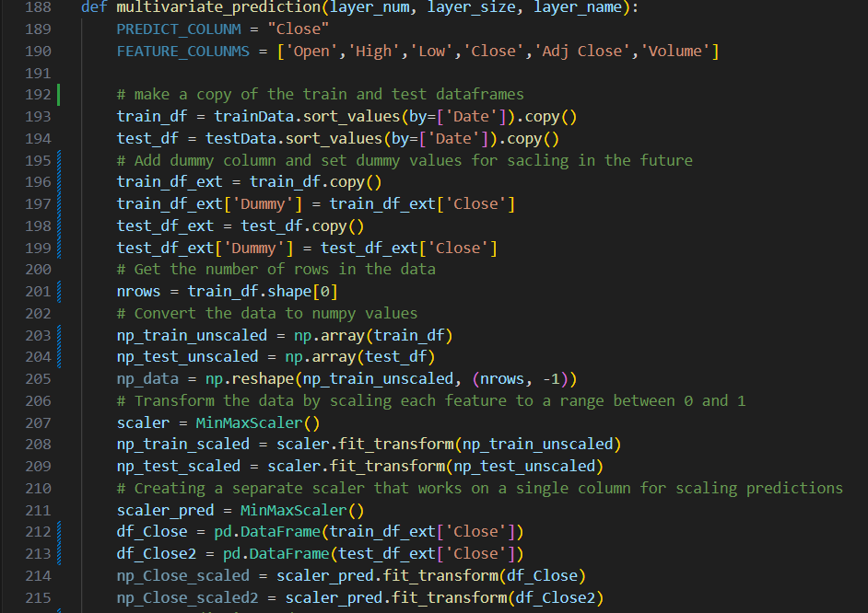

The ‘sliding window’

The making of the model

Multivatiate predicted data on a graph:

Subtask 3:

The final subtask was to make it so both the prediction data from subtask 1 and subtask 2 displayed on the say graph. This was very easy to do as all I had to do was input the multivariate data on to the graph and it displayed.

References:

**Follonier, F 2020, *Stock Market Prediction using Multivariate Time Series and Recurrent Neural Networks in Python*, relataly, viewed 21/09/2023, <https://www.relataly.com/stock-market-prediction-using-multivariate-time-series-in-python/1815/>.**